Information Book

Our Vision
RESPECT for Self, People, the Environment and Opportunities

Our Mission Statement
To develop independent, proactive students who give back to society by developing attributes in our acronym - RESPECT: Responsibility, Educational Ownership, Self-Awareness, Poutama, Environmental Action, Character Development and Tangata.

Opoutere School
S.H. 25
Tawa Tawa
R.D. 1 Whangamata
PH– (07) 865 9077
office@opoutereschool.net

Welcome
A warm welcome to all students and families to the 2020 academic year. The staff are all delighted to have you back and we welcome all new students. We endeavour to achieve high standards of academic study through a holistic curriculum. Consequently, the development of sound work habits and a positive attitude to learning are a focus. We aim to have close co-operation between home and school and we welcome open lines of communication throughout the year.
Please keep this info book in a safe place as you may need to refer to it throughout the year.

STAFF

Principal | Mr Jethro Dyer
Deputy Principal | Mr Matt Sheales
Teina Hub | Kakano Teacher  Ms Emma Driver | Yr 0 & 1
Teina Hub | Kowhai Teacher  Ms Natalie Keogh  Miss Michelle Bourke | Yr 0 & 1
Teina Hub | Rimu Teacher  Mrs Whaea Brooke Duffull | Yr 2
Teina Hub | Pūriri Teacher  Mrs Annelies Resink | Yr 3/4
Tuakana Hub  E.O.T.C & Te Reo Maori | Totara Teacher  Mrs Laurie Webb  Matua Ryan Thompson | Yr 5 & 6
Tuakana Hub | Kauri Teacher  Mr Matt Sheales | Yr 7 & 8
Administrator:  Finance Officer | Mrs Stephanie Noa  office@opoutereschool.net  Mrs Caryl Cullen | Teacher  Aides | Rachel Gordon  Bridgette Moore  Crew Smyth  Anisha Venter
Kapa Haka | Matua Ryan Thompson
Allgreenz Envirogroup | Mrs Laurie Webb
Caretaker/Cleaner: | Mr Kurt Jacobs

Board of Trustees
Board of Trustee meetings are held at 6.00pm in the school Staff Room and are usually on a Monday of each month. You are welcome to attend these meetings and if you would like to address a meeting you must request to do so in writing, briefly stating your intended topic, by the Wednesday preceding the meeting.

Mr Anton Dorreen
Mr Phil Keogh
Mrs Gina Kennings
Mr Steve Trebilco
Ms Hannah Hoffman
Mr Matthew Sheales - Staff Representative
Mr Jethro Dyer - Principal

Hours
9.00am School starts
10.30am Morning Tea
10.50am Morning Tea ends
12.50pm Lunchtime
1.30pm Lunchtime ends
2.45pm School finishes

Term Dates
The school operates the normal primary school terms. The dates are as follows:
Term 1 - Tue 9th Feb - Fri 16th April
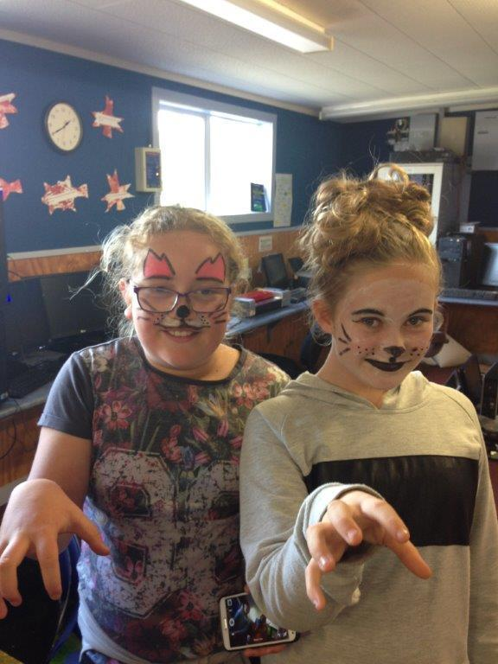
Term 2 - Mon 3rd May - Fri 9th July
Term 3 - Mon 26th July - Fri 1st Oct
Term 4 - Mon 18th Oct - Tue 20th Dec

Public Holidays
Waitangi Day 8th February
Good Friday 2nd April
Easter Monday 5th April
Anzac Day 26th April (In Holidays)
Queen’s Birthday 7th June
Labour Day 25th October

Web Site & Facebook
The school web site is found at
www.opoutereschool.net

or check us out on Facebook page
Search: Opoutere School

School Policies & Procedures
To view our School Policies and Procedures please go online to;

http://opoutere.schooldocs.co.nz

Login: opoutere Password: tawa

If you do not have access to the internet at home and you would like to access School Policies and Procedures documents, please feel free to come in to the school office and use one of our school computers.
Communication

Newsletter
We produce a fortnightly newsletter at Opoutere School. This year, the newsletter will be distributed via email, every Friday, hard copies will be available from the school office, a downloadable copy will also be available through the school website. Newsletters are one place we celebrate learning, sporting achievements, events, share up-coming events and important dates, as well as feature our Tui award and Mana Award winners each week.

Class Newsletters
Teachers will often send notices and permission slips home with children when trips and events pertain to their classes. These notices often have important information so please check your child’s bag regularly or even better get your child into a routine where they hand the notice to you when they get home.

Opoutere School Facebook
We also communicate regularly via the Opoutere School Facebook page. This is a quick and effective way to stay up to date with regular communication.

Opoutere School Website
Our school website also has important information, including our latest newsletters. Our school calendar can also be viewed here.

Friday Assemblies
At 2pm every Friday during the term, we hold a whole school assembly led by our Year 7 & 8’s, which we welcome parents and caregivers to attend. Assemblies are mainly a celebration of learning and efforts our children have demonstrated over the week but will often feature additional notices or weekend event notices.

Meet with Staff
All of our Teachers and Staff are happy to make time to speak with parents and caregivers, we will ask that if you do require time with teachers that this does not disrupt classroom learning, our Principal is available during school hours if the matter is urgent.

Stationery
At Opoutere School we ask that parents purchase school stationery requirements through the school office in the first week of the school year. We do this for two reasons. Firstly for ease of purchase for parents, and to ensure children are receiving the best quality equipment at the best prices (Warehouse Stationery). The school has no mark up on any stationery items provided. Parents will be invoiced for the child's stationery requirements. This can be paid for by AP over the year. The most common ‘Top-up’ stationery items are available for purchase, throughout the year, through the school office e.g. Pencils, Pens, Erasers, Rulers, Sharpies, Pencil sharpeners etc.

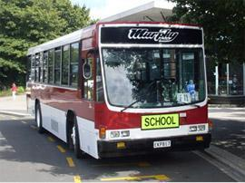
School Bus Fees
The Ministry of Education will not fund children’s bus travel when families choose to send their child(ren) to a school other than the nearest appropriate one. The Board of Trustees continues to subsidise the cost of bus travel to help minimise this cost.
Individual $65 per term. (6.50/ week or $1.30 return trip per day)
Family $115 per term. ($ 11.50/ week or $2.30 return trip per family)
We ask that bus accounts are settled at the beginning of each term and an invoice will inform you of the amount of bus fee still owed. Bus fees are compulsory if your child or children catch the bus unless they live within the designated distance from their nearest appropriate school. The current distance is:
Students from Years 1 – 8 must live at least 3.2km from their nearest appropriate school entitlement zone.
Payment can be made via internet banking or in person to the office. Options are also available to set up an AP to spread this cost over the year.
Bus changes:
Should your child/children be getting off the bus at a stop other than the usual, or you wish your child/children not to go on the bus for any reason, the school must be notified, otherwise we will instruct the driver to let your child/children off at their regular stop. If your child is being picked up by another adult, we must be informed of the change in writing or by phone. We will not accept children verbally telling us that their bus arrangements have changed as they can sometimes get the wrong message. Therefore, please phone/send a note to the school before lunch to notify us of any changes.

Bus Behaviour and Rules
An Opoutere School Bus Code of Conduct specific to bus travel is sent out to all children who travel on the bus at the beginning of the year. Please read and complete the Code of Conduct with your child/children and return to us to file.

Opoutere School Bus Code of Conduct
I will:
- Sit quietly in my seat
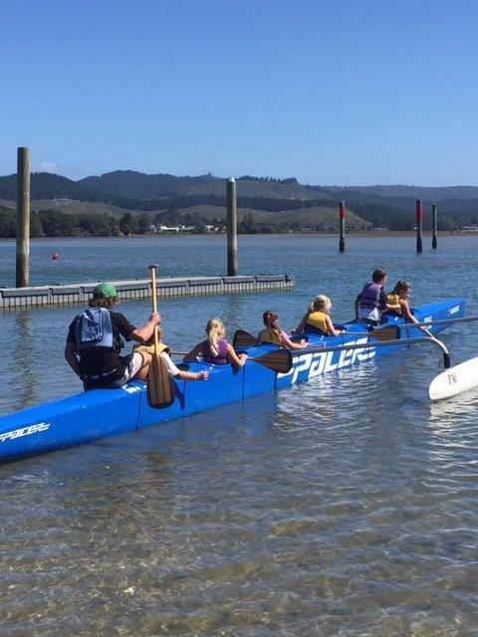
- Put my bag on the floor at my feet
- Stay in my seat while the bus is moving
- Wait until the bus is stopped before I leave my seat
- Walk sensibly from the bus when I get off
- Use the Opoutere School Expectations

I will not:
- Throw anything out of the bus
- Eat or drink on the bus
- Distract the driver while the bus is moving
- Be disruptive or annoying to other passengers

If it isn’t fully contained in a school bag it won’t be allowed on the bus.
Donation Scheme
Opoutere School has opted into the Donations Scheme. What this means for you as parents is that the board of trustees cannot ask you to make a donation unless it is for an overnight school/kura camp – and then you can choose if you want to pay none, some or the entire donation. If you choose not to make a donation, your child cannot be stopped from attending a camp if it is part of the school’s core learning programme (curriculum).
· Bus fees will still need to be paid by parents
· Visiting Tech fees will be covered by the school
· Stationery will be a cost to parents
· You cannot be asked to make either a general or specific donation e.g. a donation for a day trip to a museum or a field trip to a hiking track.

Further information can be requested from the school.

Absentees
All children are expected to attend school by regulation unless prevented by special circumstances or illness. Opoutere School is committed to ensuring that all of our students get the most out of their education, and wishes to support our students to maintain regular attendance. Students who attend school regularly learn more and achieve better results.
The Ministry of Education Regulations require all absences to be satisfactorily explained. Please phone by 9:30am if your child will not be at school. We would ask that, where possible, parents avoid taking their children out of school during school hours as this can be very disruptive to your child’s schooling. We do understand that it is not always possible to make doctor or dentist appointments after school but ask that you do so where possible.

Changes of Address
Please inform the school promptly of any changes in your address, landline number/ mobile number and email address. We must be able to contact you or a trusted caregiver in case of an emergency or illness.

Behaviour
The children at Opoutere School behave very well and we are proud of the way they play together and respect their teachers, school and visitors. The behaviour we have is relative to the vigilance of the staff and the expectations of parents. It is essential to have a school environment in which children feel secure for optimum learning. All members of Opoutere School are entitled to belong to a learning community that fosters an intrinsic approach to behaviour management through the creation of a safe physical and emotional environment. Our behaviour management is based on our strong relationships we have with our students and seeks to manage behaviour through restorative practices.

Swimming
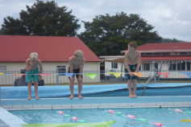
Swimming is an integral part of the Physical Education programme and all children are required to take part in Term 1 and the latter half of Term 4. If, for any reason, your child/children cannot swim on any given day or period of time, a note or a phone call is essential.
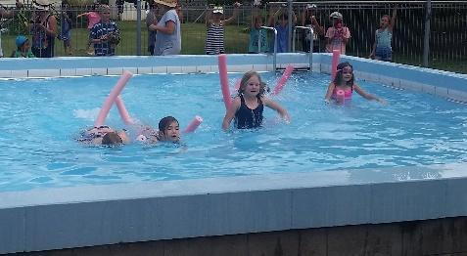
Children need suitable togs and a towel, both of which should be named and in a togs or plastic bag. We cannot allow children to wear cotton t-shirts in the pool as they draw chlorine from the water and make it difficult to keep the water quality safe. Rash shirts, wet suits and other items designed specifically for swimming are permissible. Children with long hair are requested to wear their hair up. Supplying your child with sun-block is advisable.

Clothing
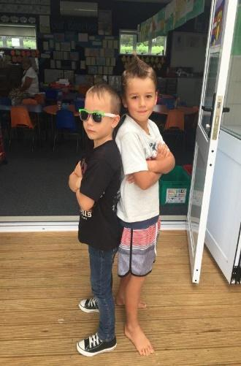
Please ensure your child dresses appropriately for school. No high heels or midriffs showing. Clothing should be suitable for daily fitness. PLEASE NAME ALL YOUR CHILDREN’S CLOTHING. At times through the term lost property will be returned at assemblies. All unclaimed clothing will be given to the Opportunity Shop at the end of each term.

Valuables
We ask that children do not bring valuable toys or other items to school as we cannot ensure the safety of these items. The use of mobile phones is prohibited at school. Any children who bring a phone to school should hand it to their class teacher and collect it after school. Yr 7/8 students may apply for approval to have electronics on the bus through the principal.

Visiting Tech (Manual)
Technology for Year 7 and Year 8 children is at the Whangamata Area School. Children are to wear closed shoes when doing workshop and without these they cannot go. Transport to and from manual is provided. The cost for Manual is $20 per term per student and is covered by the school.

Te Reo Mäori me öna Tikanga
All children receive some instruction in Te Reo Maori. The main focus of this programme is te reo and basic tikanga. This programme is taught by staff and supported by Matua Ryan. This is a compulsory part of the school programme. Opoutere School has a large Kapa haka Group, both senior (Tanemahuta) and junior (Puawai) This is optional and requires a certain level of commitment from the children in the groups.

Cultural Connections
Students are given the choice to elect into one of three options – Te Reo and Digital Media, Kaitiaki Crew and Kapa Haka. Cultural Connections happen every Thursday afternoon after lunch. Students choose one of the three options at the start of the year.

Adventure Learning
This is an exciting and unique part of the Opoutere School curriculum. Adventure learning looks to develop the following core values; Adventure, Environment, Leadership, Service, Excellence and Tikanga/ Te Reo. Students in each class explore the following themes throughout the year:

Term 1: Te Moana / The Ocean
Kayaking / Conservation / Environmental Studies / Marine Science / Water Safety

Term 2: Matariki / Māori New Year
Tikanga / Te Reo / Astronomy / Leadership / Māori Games & Art / Gardening / Service
Term 3: Te Whakataetae / Adventure Racing
(literal translation – competition)
Navigation / Teamwork / Fitness / Leadership / Strategy / Maths / Bushcraft / Survival

Term 4: Te Haerenga / Expedition
Safety / Risk Management / Planning / Teamwork / Leadership / Geography

All students participate at their level. Safety is paramount and EOTC guidelines adhered to when managing these activities. Teina have Adventure Learning on Wednesdays and Tuakana on Thursdays. A blanket consent and medical form is sent home at the start of the year to cover day trips. Overnight trips require separate parent consent. Other notices will come home informing parents of particular gear children may need and on what days. The BOT employs a specialist adventure learning teacher, Matua Ryan, as part of its ongoing commitment to this unique programme.

Sun Safety
All students must be sun safe. In Terms 1 and 4, students must eat their lunch under the shaded areas provided (i.e. the Wharekai or under the shade sails) and must wear hats in the playground.

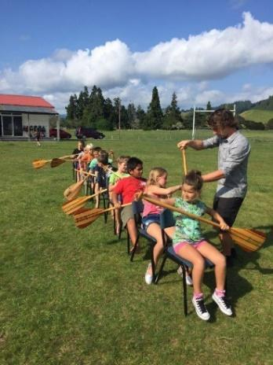
Reporting to Parents
End T1 - Junior and Senior Showcase
End T2 Student achievement reports
End T3 - Junior and Senior Showcase
End T4 - Student achievement reports
If classroom teachers feel there are any concerns or celebrations to be had around a child’s learning, they will make contact with parents regarding these. Please don’t be afraid to make contact with your child’s classroom teachers, they are all more than happy to talk with parents and caregivers.

Issues and Concerns
There may be times when you have concerns about aspects of your child’s education, social or emotional wellbeing. On these occasions, it is important that you bring your concerns to the school via your child’s classroom teacher or the Principal, as we want to deal with your concerns immediately within the school environment.

Administration of Medicines
If your child suffers from an on-going illness i.e. asthma, it is important to let the school know as soon as possible after their diagnosis. It is also imperative that parents or caregivers sign a medication administration consent form, that outlines the medication to be administered and the recommended dosage.
Please do not send your child to school with medication, they are not permitted to carry or administer their own medication at school without adult supervision. If your child is on antibiotics that requires refrigeration, we ask that you administer this at home when your child gets off the bus, then again at bedtime.

Calendar of Events
February/March Swimming Sports
WHOT Swimming Sports

March/April TVPS Swimming sports
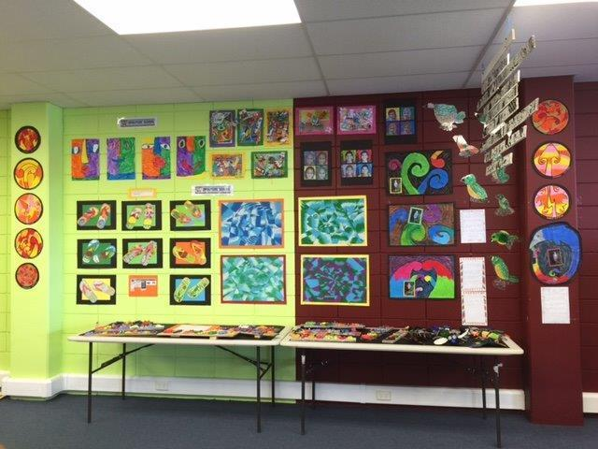
Beach Hop
April Reports to parents
May Opoutere School Adventure Race
June Grandparents Day / Mataariki Celebrations
Reports to Parents
July Classroom Learning Showcases
August Cross Country
September Classroom Learning Showcases
November Snr WHOT Sports (Athletics days)
School photographs
Nov/Dec Reports to parents
December Break-up night (Prize-giving)

Jethro Dyer
Principal

